**Cache clearing or rebuild clientlibs / JSPs**

**To clear clientlibs cache or to rebuild libraries, follow the below steps.**

1. Access the below mentioned console URL.

<http://localhost:4502/libs/granite/ui/content/dumplibs.rebuild.html>

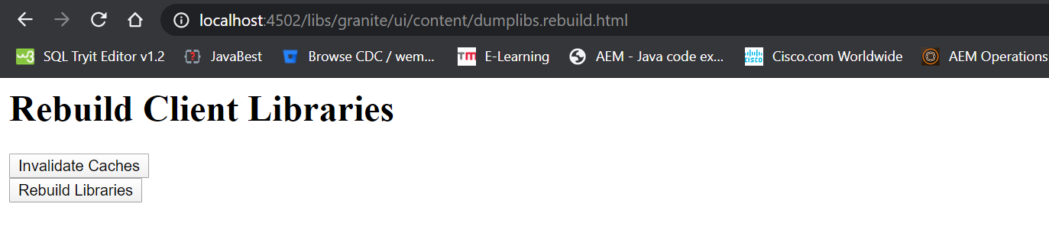

1. You will be provided with two buttons. Click on the appropriate button to perform the task.
2. Once the operation is performed, cache would be cleared, or the libraries would be rebuild based on your choice.

**Note:** These two operations can be directly performed via URL itself, instead of clicking on the buttons.

To clear the cache - <http://localhost:4502/libs/granite/ui/content/dumplibs.rebuild.html?invalidate=true>

To rebuild the clientlibs –

<http://localhost:4502/libs/granite/ui/content/dumplibs.rebuild.html?rebuild=true>

**Rebuild JSPs –**

1. Go to the felix console (<http://localhost:4502/system/console> )-> Sling -> JSP (or) can directly navigate to the console by accessing the below URL.

<http://localhost:4502/system/console/slingjsp>

The JSP felix console looks like the one mentioned below.

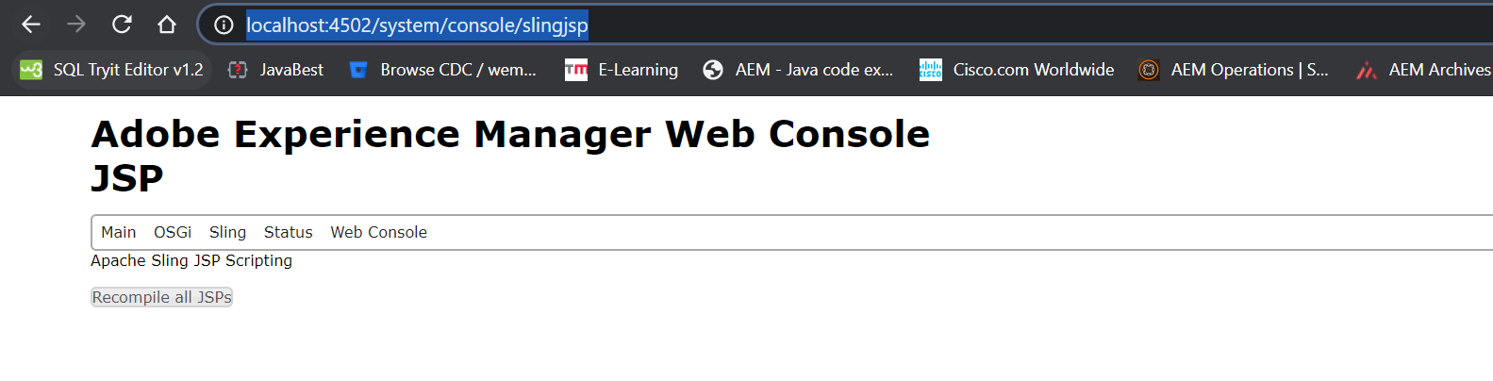

1. Click on “Recompile all JSPs” button and upon successful completion of this task, we would see a message like shown below.

